Yamaha Corporation has released another powerful product in their successful synthesizer workstation department: the Yamaha MX88. Here is what you need to know about the Yamaha MX88.

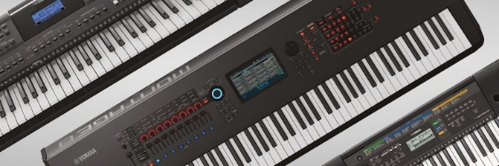

*Source: Yamaha Corporation*

**Size, Weight, and Color.** The MX88 weights around 30 lbs., with a width of 52 inches, height of around 6.6 inches and a depth of around 16 inches; this product exclusively comes in black.

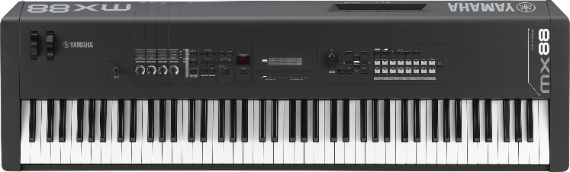

*Source: Yamaha Music*

**Onboard Controls.** Located on the left-most side of the MX88 is a pitch bend wheel, modulation wheel, four assignable knobs, MASTER VOLUME knob with KNOB FUNCTION, PART 1-2 LINK and DAW REMOTE buttons. TRANSPOSE, OCTAVE, STOP and PLAY buttons are also available near the left of the console. In the center of the console sits the main LCD screen for the console as well as a 3-digit screen for PERFORMANCE NUMBER and SELECT button underneath the PERFORMANCE NUMBER screen. Next to this is a FILE, UTILITY, EDIT/COMPARE, JOB and STORE buttons. To the right side of the MX88’s onboard controls panel, there is a large black DATA dial located near the center of the synthesizer. A SHIFT, EXIT, 4-way directional buttons, DEC/NO, INC/YES, ENTER and EXIT button next to the DATA dial. And at the far right of the MX88 is a LAYER, SPLIT, ARP, RYTHMIC PATTERN, EXT. SONG, TEMPO and PART SELECT BUTTON. There are 16 different white sound buttons on this console, including PIANO, SYN LEAD and SOUND EFX to name a few.

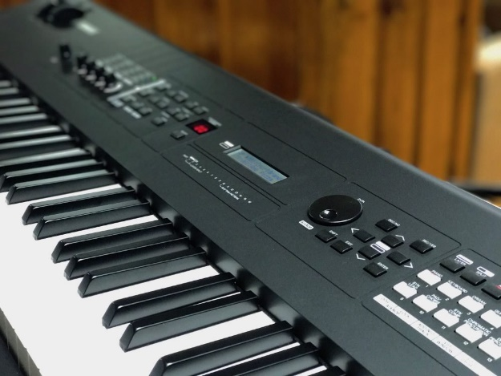

*Source: Guitar Junky*

**Touch and Feel.** The MX88 features an 88-key Graded Hammer Standard (GHS) weighted action. This technology acts to resemble that of a real Grand Piano with heavier response in the lower register keys and lighter response in the higher registers, providing acoustic feel and touch to the product. Also integrated is matte black key tops that will absorb moisture after extended use, ensuring keys do not become slippery over time but remain tactical and responsive.

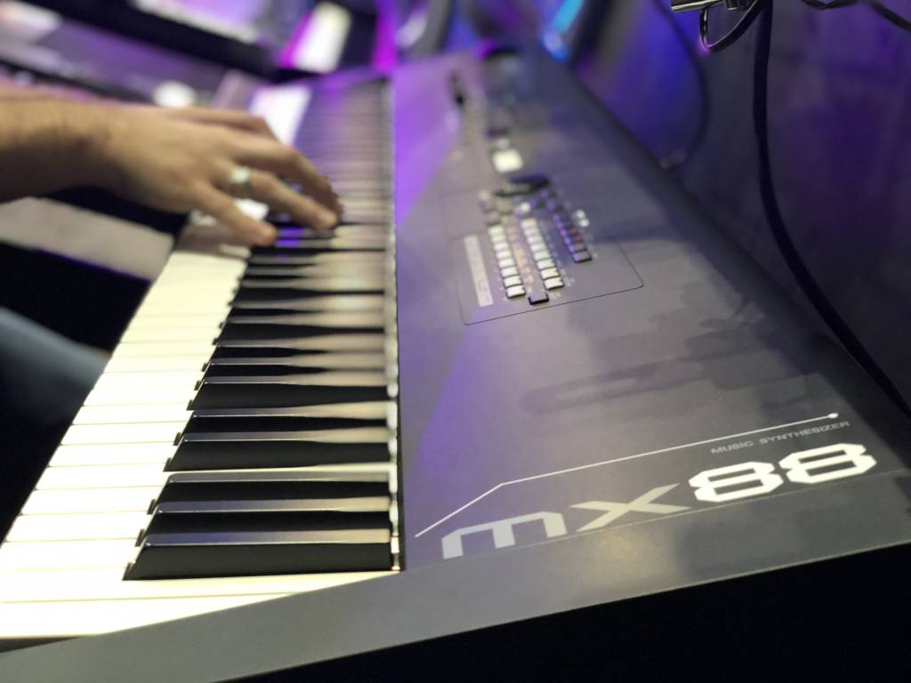

*Source: Sims Music*

**Voices and Effects.** This product comes from the famous MOTIF line sporting a powerful low end, detailed midrange, and crisp high end full concert grand piano voices. Paired with this, Yamaha has included an optimized touch curve in this product providing players with high expression and realism. The MX88 also includes over 1,000 voices at on board such as electric pianos, organs with rotary speaker effects, strings, guitars, basses, drum kits and other percussion instruments. The MX88 is additionally equipped with Yamaha’s Virtual Circuitry Modeling (VCM) FX engine, which helps model old school 1970s effects such as EQ presets, phasers, flangers, wah-wahs and much more. Effects in this product include 42 reverb, 88 chorus and 267 insertion effect presets, as well as a 5 band master EQ.

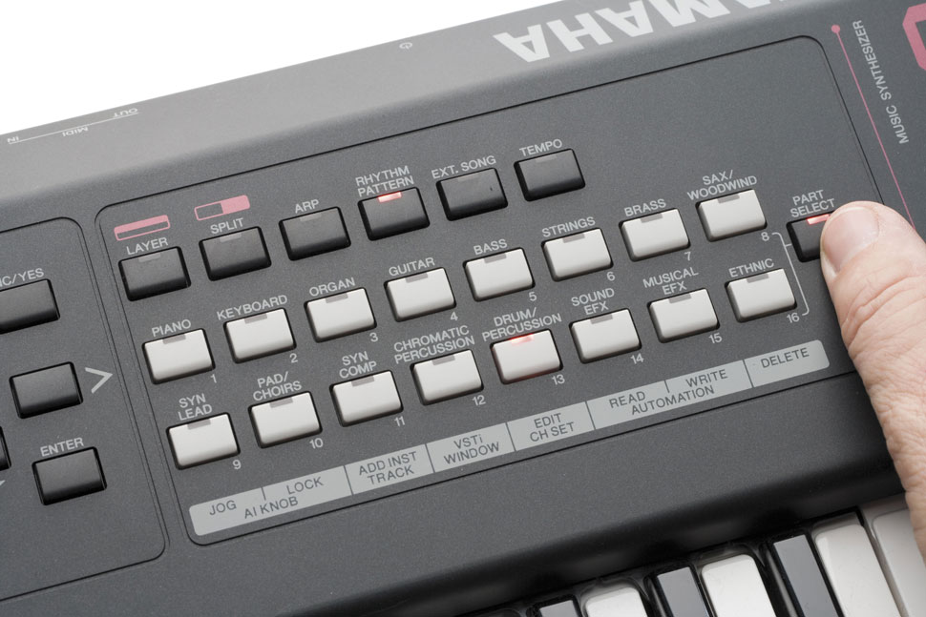

*Source: keyboards.de*

**Polyphony Capability.** The MX88 has 128-note polyphony. This means up to 128 notes can be played at a time before experiencing dropout when playing live or with track sequences allowing you more flexibility.

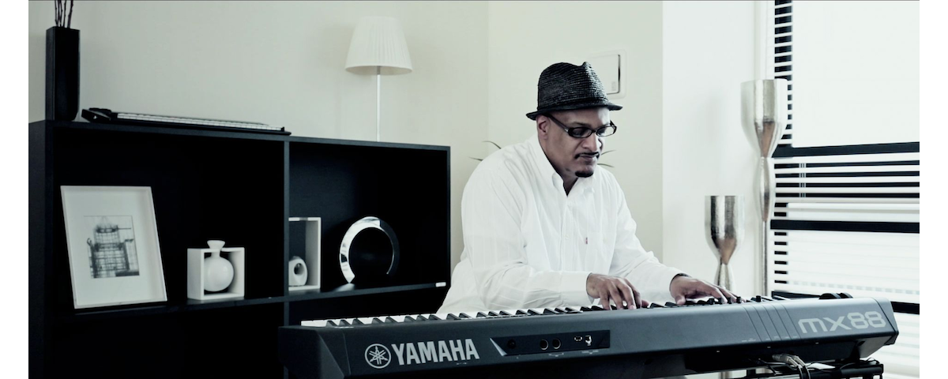

*Source: Yamaha.com*

**Software Compatibility.** There is USB audio and MIDI compliance connectivity with this tool and can be integrated with not only iOS applications, but MAC and PC-based DAWs in addition. Compliant digital tools include Cubase 8 or later, SONAR X2 Producer for Mac, Logic Pro X, Digital Performer 9, Ableton Live and several other DAWs not listed here for live performances, editing, mixing, or recording. Compliant VST plugins can also be used such as the Steinberg VST available on MAC and Windows systems.

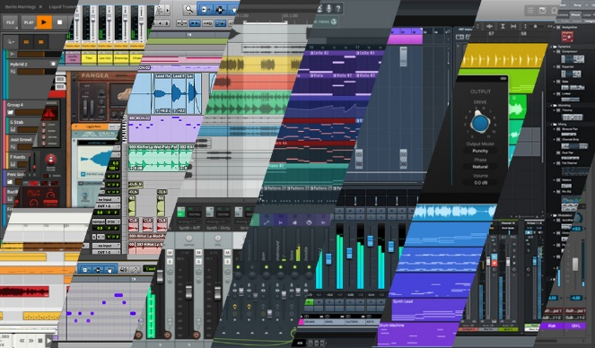

*Source: beat bars*

**Connectivity.** The MX88 includes L (MONO) and R standard phone jack outputs, a PHONE standard stereo TRS output, FOOT CONTROLLER, SUSTAIN, MIDI IN and OUT connection, USB TO HOST / TO DEVICE connection and AUX IN connection as well as the standard DC IN 9-watt power supply connection. This keyboard also automatically shuts off during longer periods of inactivity.

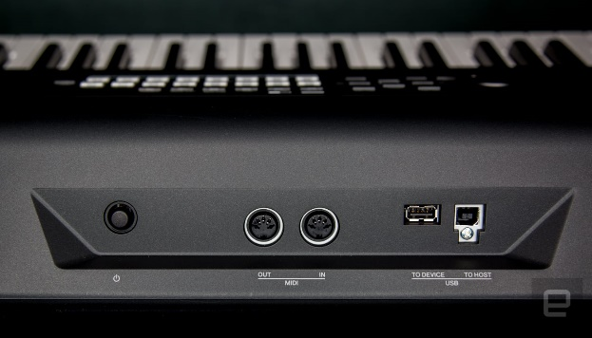

*Source: Engadget.com*

**Price.** Sourcing from Sweetwater.com, Amazon.com and Guitar Center, the MX88 will go for $1,200. Some bundles will include a stand, bench, headphones and a sustain pedal for $100. However, this product can be found used for around $750-$850 on sites like eBay, Sam Ash and Reverb.



*Source: Killer Guitar Rigs*

The MX88 is another high-performance product from Yamaha’s Synthesizer Workstation line. At 30lbs, this synthesizer can be transported. There are more than 1,000 MOTIF XS sounds with class compliant connectivity. There are 88 full-sized, GHS weighted keys that have been fitted with some of the best technology from Yamaha allowing for more expressive and realistic playing. On top of this, various VST plugins and DAWs can be used with this synthesizer as a controller.



*Source: Redbubble*